**Functional Specification**

**Contents**

1. Goals
2. Current State
3. Scope
4. Standards, Laws
5. Current business model
6. Requested business model
7. Requirement list
8. Use cases

**1.Goals**

Our team accepted a project of making a competitive hanged man game. The game must be playable online versus other players or the computer. Every result is stored on the server in a database. There will be „Ranked” and „Unranked” games. The later is a single game, where the results are basicaly meaningless, while the former is working like a single-elimination type championship. After defeating the opponent, the server automatically chooses the next one, until someone wins the current championship. The actual game will be used on the first Hanged Man world championship. For this reason, testing will be a crucial point durring the development cycle.

**Durring development our goals are:**

* Playable hanged man game (vs. Computer)
* Player vs. Player online mode
* Store results
* Championship mode
* Campaign mode
* Infinite mode

**2. Current State**

Everyone has always liked the famous hangman game, due to its low difficulty and the joy it spreads among people. Despite these charming aspects, the game itself had not got a great online multiplayer platform. People use a piece of paper and a pen or pencil to play. It is very ineffective, since playing on a paper makes our paper storage empty just in a minute or two, and in the long term, it can lead to the disappearance of several rainforests and natural habitats. The players usually play alone, with low multiplayer possibilities, which can be quite frustrating and can lead to depression. Therefore an online platform shall be created for this amazing fun activity, including solo, and multiplayer mode.

**3. Scope**

We are going to develop a web application for the client, that will make the hangman game even more popular with new possibilities and amazing game modes. The user has to provide their data to register. These informations are going to help us making statistics and improving the user experience. The game has four differnet game modes:

1. **Hangman Worldcup**: It is a multiplayer mode, where players around the world can play against each other in a competitive way. The Worldcup has an elimination race, where the users play one by one, and in the final, the two top players play a final match.
2. **Practise Mode**: There is an easy way to practice for every user to develop themselves. In the single player or practice game mode, the person needs to find out the words that the computer generates randomly from the game database.
3. **Local 1v1 Mode**: It is a really fun game mode, players have the chance to play with their friends in a divided screen. They have to guess words given by the opponent. The fastest one wins the game.
4. **Campaign**: From time to time the Hangman game will introduce the story mode of the game, wich is going to be a story-based campaign adventure, where the best conquerors will get precious gifts.
5. **Infinite Mode**: We would like to suggest an additional game mode, in which players can test their mind and enhance their percepsion at the same time. The Infinite mode introduces a never ending level mode, with a timer that becomes tightes and tighter. If the timer reaches zero, the game ends, and the points will be saved. Clearing a level adds more time to the timer making it a bit easier to get further. Obviously, it has no end, so it can not be beaten. However, people can compete with their high scores.

The background of the application is goign to be a huge Oracle SQL database, with the pieces of information about the registered users and the necessary items to the gameplay. The data will be stored in the databse, so noone will be able to get these informations about the players, making the application safer. The database will serve important statistic values, so players can easily see how many matches were played in the given day or week, what is the number of the current user base, and with these informations, we can make statistics about the popular game mods and which country has the biggest number of players. If the program gets some server issues in the multiplayer mode, it will send emails to all the users of the game. Furthermore, the application is going to have a Sponsor page, where people who support the emergent system, the functioning and the user's prizes and the defense of the datas, will receive their proper regards.

**Additions:**

1. We can make the web application to run on Andorid and IOS devices smoothly in scalign resolution, making the game more mobile, and easier to reach. However, it will not support Windows phones.
2. We reccomend to implement some sort of Daily login prices, making players come back to the game more frequently.
3. We could make the users profile more developed, for example, profile picture, visual statistics, Username, Highest scores in each gamemode, etc.
4. Infinite game mode: see in 3.5.

**4. Standards, Laws**

**General Standards**

Application must meet the following general standards:

1. Must be easy and intuitive to use for the target audience.
2. Must function in a logical manner for the target audience.
3. Must use the industry best practices.
4. Must use styles that are consistent throughout the application and within the associated Web site, including:
   1. Error messages must appear in a consistent location and style and must provide sufficient information.
   2. Form controls that are not available must be hidden.

**Development Technology, Programming Language, and Web Server Software**

Web application requires the use of the following (or higher) technologies:

* Ruby 2.6.3
* Rails 6.0.0
* MongoDB 4.2

Recommended:

* RubyMine 2019.1 Development environment

**Minimum Browser Standards**

Web application must function and display properly in the following browser versions:

* Internet Explorer 11.0
* Mozilla Firefox
* Apple Safari
* Google Chrome
* Microsoft Edge
* Opera

The application require the Web browser to support Javascript and to accept session-based cookies

**Application Testing**

Web applications and sites must be thoroughly tested in all required browser versions in screen resolutions of 800×600, 1024×768, 1360×768 and 1920×1080.

**7. Requirement list**

|  |  |  |  |  |
| --- | --- | --- | --- | --- |
| **Modul** | **Id** | **Name** | **v** | **Description** |
| Database | D1 | Database planning | 0.1 | Database, tables, relations |
| Authorization | A1 | Log in | 0.1 | Log the user in |
| Authorization | A2 | Register | 0.1 | Register new user |
| Game | G1 | Generate word | 0.1 | Get random word from database |
| Game | G2 | User interface | 0.1 | Design GUI |
| Game | G3 | Game Mechanics | 0.1 | Implement mechanics |
| Championship | C1 | Championship | 0.1 | Championship implementation,1v1 mechanics |
| Site | S1 | Sponsor Page | 0.1 | Site about Sponsors, About, Social Media? |
| Site | S2 | About Page | 0.1 | Description of the game, how to play, etc |
| Game | G4 | Game Page | 0.1 | Interface of the actual game |
| Statistics | St1 | Statistics Handle | 0.1 | Store data about login, matches played, etc |
| GameMode | GM1 | WorldCup | 0.1 | World Cup game mode |
| GameMode | GM2 | Practice | 0.1 | Practice game mode against CPU |
| GameMode | GM3 | Coop | 0.1 | Coop 1v1 Game mode |
| GameMode | GM4 | Campaign | 0.1 | Solo Campaign game mode |
| GameMode | GM5 | Infinite | 0.1 | Infinite game mode |

**5. Current business model**

At the moment the customer has a working website, which provides every necessary information about the championship, Although playing is not yet possible. Our current project aims to extend the functionalities of the current website by providing a playable game in the browser.

**6. Required busines model**

**Pre-conditions**

* Both parties need an internet connection to register, login and play matches.
* A server is required for the application to function properly.
* gettign sponsors is a crucial point in the game development.

**8.** **Use cases**

1. When the user runs the web application the starter page will open up. It is a login window, where the user has several options here, first, register to the game with an email and a password with the Register button.

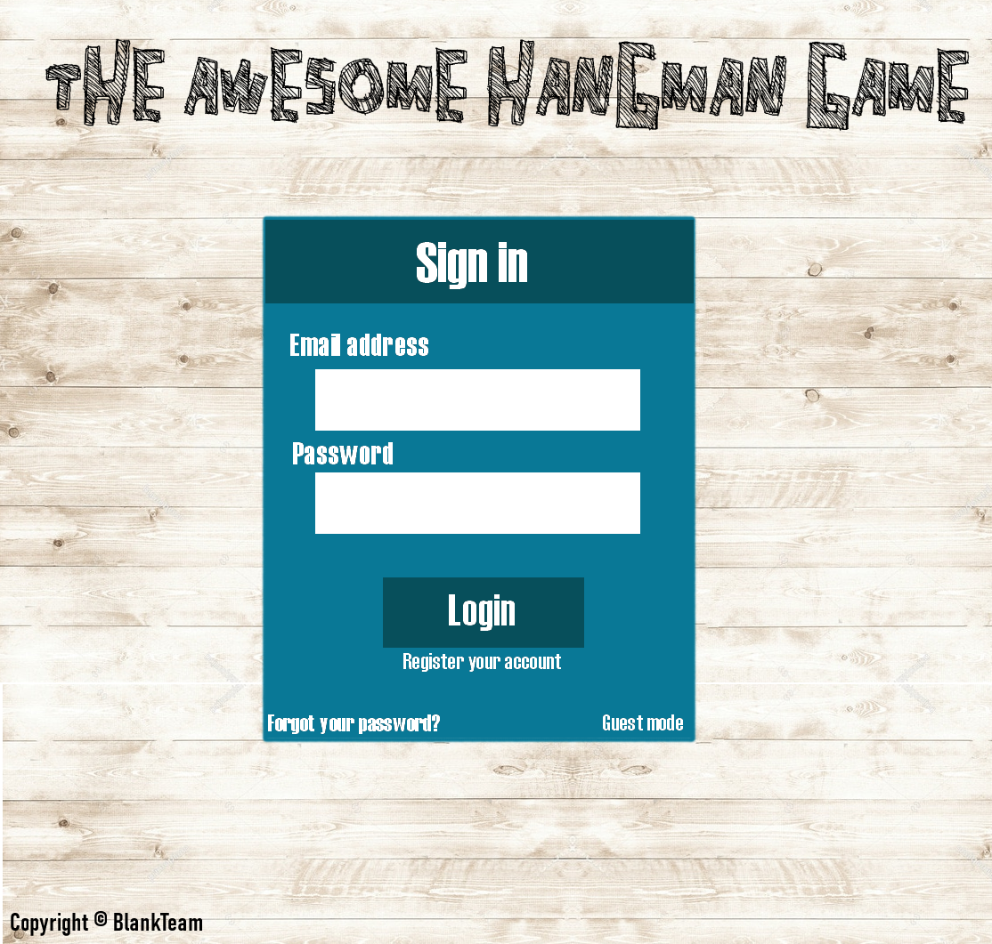

1. then users can enter the program with the Enter button or if they do not want to register, they will appear as a guest in the program. In this case, data about the processions of the user will not be saved. After all the program’s main page will expand.

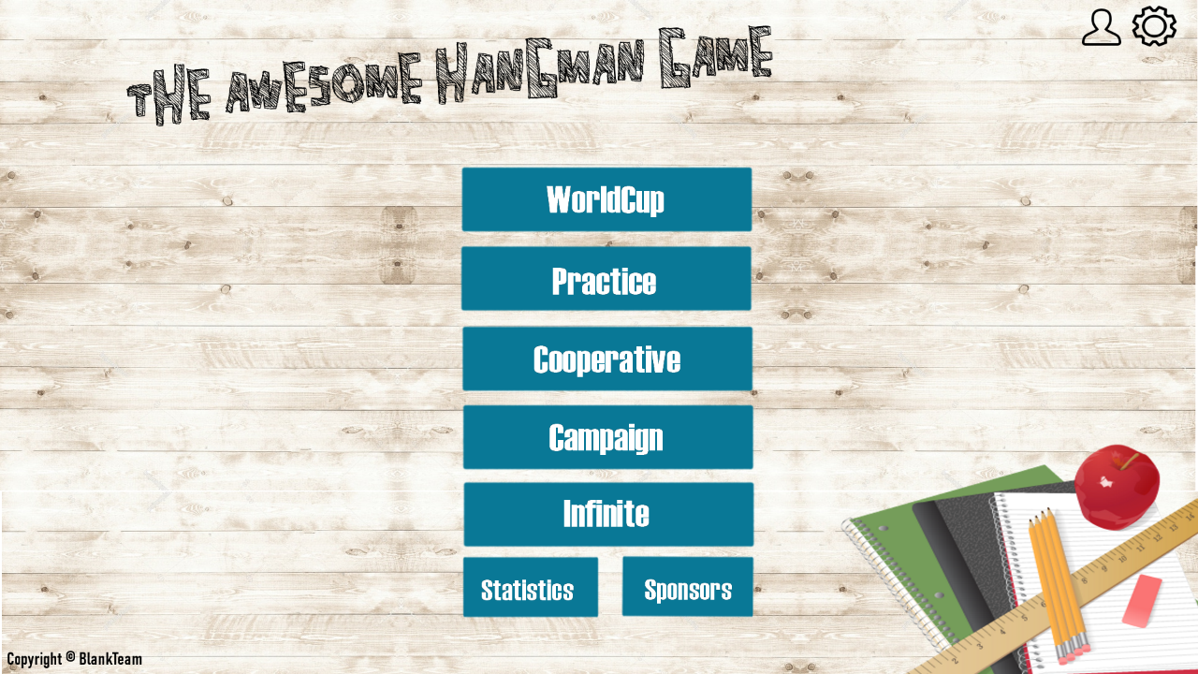

1. In the upper right corner stand two buttons for the User and the Settings. These buttons open up new separete windows.
   1. With the User button, the player can choose a new profile picture, manage data, passwords, or set their country to public.
   2. In the Settings window, the screen area is controllable, the user can choose from different themes, background music and resolutions.
2. there are several buttons for the game mods: World Cup, Practice, Cooperative, Campaign, and Infinite.
3. Inside the game modes is a new table for the match and a few information about he opponent/s, the time and a short description for the actual gameplay, plus a virtual keyboard for the guessing.

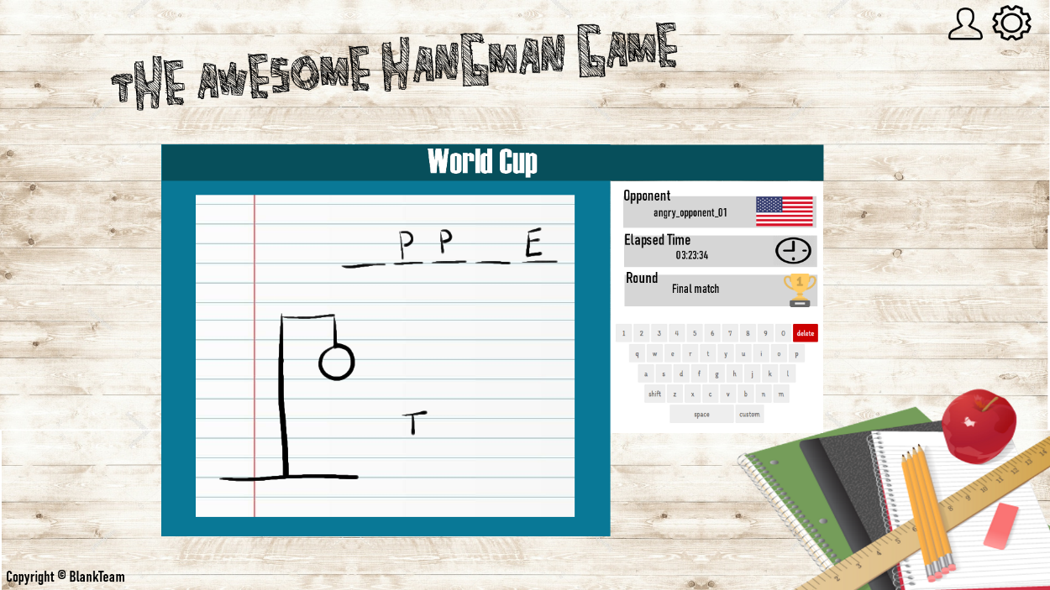

1. The last two buttons are for the Sponsors and Statistics. These two will open a new page for the supporters of the game and the statistics about the users and their playing habitat.